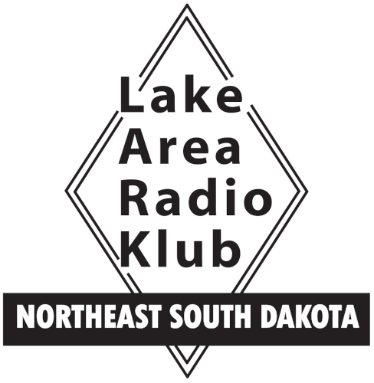
LARK Membership Application
Lake Area Radio Klub, Inc
P.O. Box 642
Watertown, SD 57201-0642
www.w0wtn.org

Type of Membership Applied For:

______ Full Membership (requires a current Amateur Radio License)

______ Associate Membership

Full Name ____________________________________________________________________

Callsign ____________________________ License Class ____________________________

Address _________________________________________ Tel # ______________________

City _____________________________________ State __________ Zip code ___________

E-mail Address _______________________________________________________________

ARRL Member? ___________ * Request LARK Newsletter ___________

* Two full members in one family may not want two newsletters

As a member of LARK, I understand I will possess the privileges of membership including use of repeaters, club stations, and subscription to the club newsletter. I agree to the conditions of membership as described in the Constitution and Bylaws of this club. If applying for “Full Membership”, I agree to pay annual membership dues of $25 per year, which are subject to change. Payment for first year’s dues will be submitted with this application.

Applicant Signature _________________________________________ Date _____________

Approved __________________________________________________ Date _____________
President
Member # _______________

Completed form may be scanned and submitted via e-mail to hamradio@dwarrick.com or in-person at any official LARK event. Membership will be reviewed for approval at an official Business Meeting.

Make checks payable to LARK Rev 11-24-25

