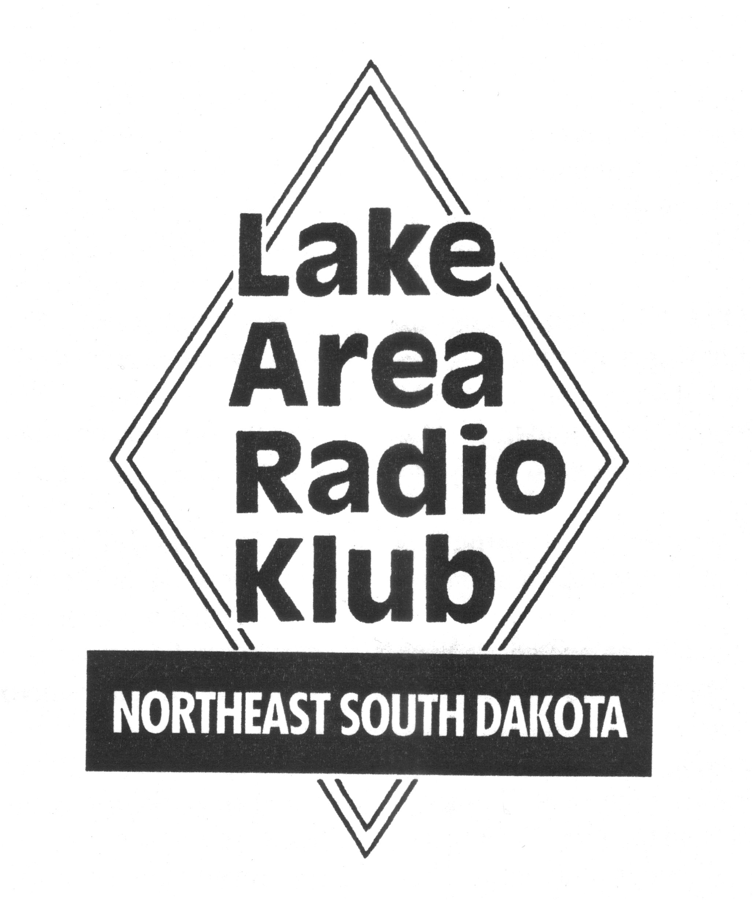
LARK Membership Application
Lake Area Radio Klub, Inc
P.O. Box 642
Watertown, SD 57201-0642

Type of Membership Applied For:

______Full Membership (requires having a current Amateur Radio License)

______ Associate Membership

As a member of LARK, I understand I will possess the privileges of membership including use of repeaters, Club Station, and subscription to the club newsletter and agree to the conditions of membership as described in the Constitution and Bylaws of this club. If applying for “Full Membership”, I agree to pay the membership dues of $20 per year at the time application is submitted.

Name: ___________________________________________ Call: _________________

License Class: ________________

Address: _________________________________________ Tel # _________________

City: __________________________ State: ______________ Zip code: ___________

E-mail Address: ________________________________________

ARRL Member? ___________ * Request LARK Newsletter ___________

Applicant Signature _________________________________ ______________
Date

Approved _______________________________________ ______________
President Date

Member # _______________

* Two full members in one family may not want two newsletters

Make checks payable to LARK Rev 6-22-24

